|  |  |  |
| --- | --- | --- |
| **Functions** | **Testing Features** | **Pass/Fail** |
| ADD MOVIES | 1. Add a Movie and check if it adds to the database and shows in the Data-grid 2. The user should not be able to add the same movie twice, the system should give appropriate error message 3. The system should not store a Blank Movie 4. Movie Genre should have proper value | **Pass**  **Pass**  **Pass**  **Pass** |
| ADD CUSTOMERS | 1. Add a customer and check if it adds to the database and shows in the data-grid 2. The system should not store a blank customer name 3. Customer name should not accept special characters or numbers | **Pass**  **Pass**  **Pass** |
| SEARCH MOVIES / CUSTOMER | 1. Search by Movie name / Customer name 2. Search should give out all results that matches the search criteria | **Pass**  **Pass** |
| UPDATE MOVIES / CUSTOMERS | 1. Should update details of the respective movie and customer only | **Pass** |
| DELETE MOVIES | 1. Should not be able to delete a movie that is rented out | **Pass** |
| DELETE CUSTOMER | 1. Should not be able to delete a customer that has rented out a movie | **Pass** |
| ISSUE MOVIE TO CUSTOMER | 1. Issue a movie to a customer and check if it adds a record in the Rented movies table, Date rented should be the current system date 2. System should not issue a movie that is already been rented out 3. Give an error message if there are no copies of the movies 4. Cannot issue more than two movies to the same customer | **Pass**  **Pass**  **Pass**  **Pass** |
| RETURN MOVIE FROM CUSTOMER | 1. Return movie should update the Rented Movies Table 2. Cannot return a movie that has not been rented out 3. Date returned should reflect the current system date in the Rented movies table | **Pass**  **Pass**  **Pass** |

# Testing Functionalities Added to Video Store System

# Snapshots of UI

# Login Form

# 

# Register Form

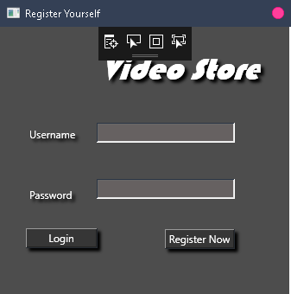

# Main UI Form

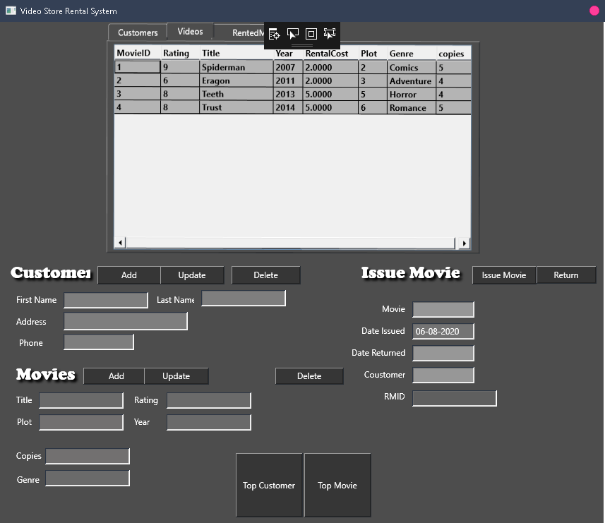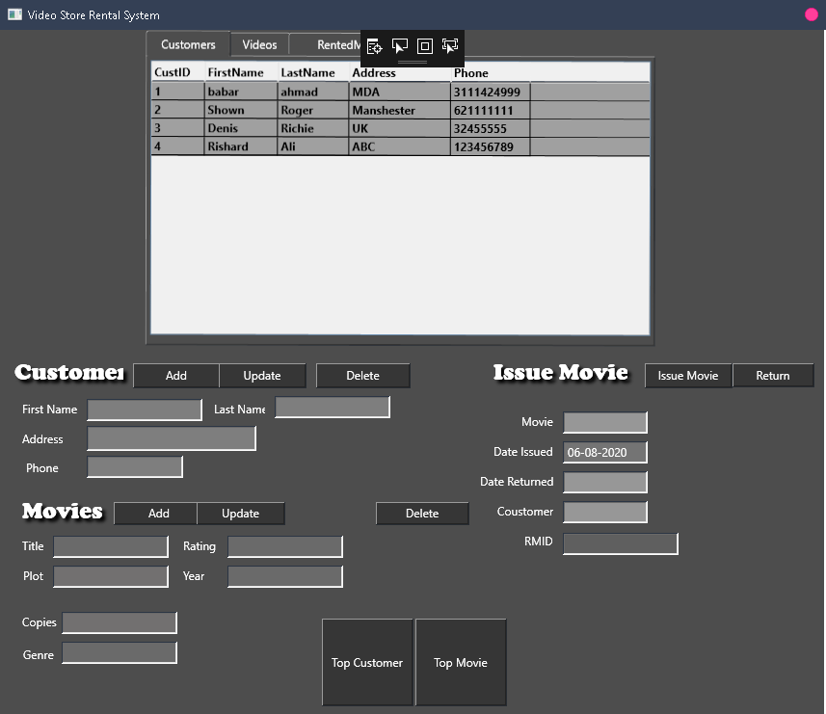

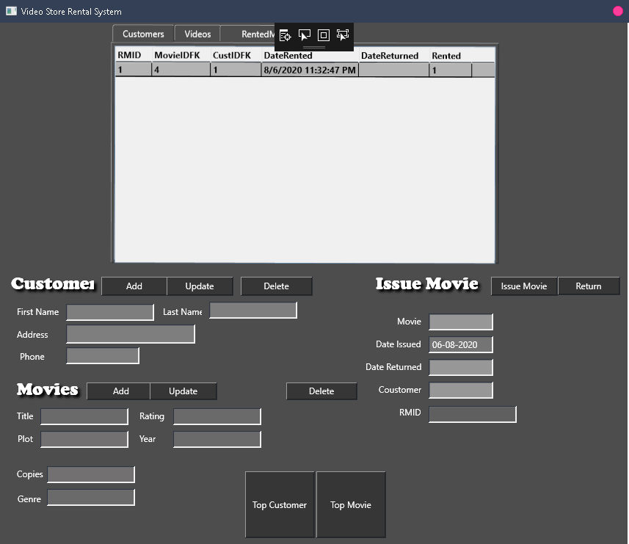

Implementation Details

**UI:** WPF

**IDE:** Visual Studio (2019)

**Database:** SQL Server (2019)

**Programming Style:** Object-Oriented